Image Derivatives and Edge Detections

1. Derivatives using loops:
2. Forward derivatives:

S = im2double(rgb2gray(imread('coins.jpg')));

[row, col] = size(S);

R = zeros(row, col);

for i = 1:row

for j = 1:col-1

R(i,j) = S(i, j+1) - S(i, j);

end

end

1. Backward:

R(i,j) = S(i, j) - S(i, j-1);

1. Central:

R(i,j) = S(i, j+1) - S(i, j-1);

1. Derivatives using convolution: (Horizontal Derivative)
2. Forward derivatives:

h = [1 -1];

1. Backward derivatives:

h = [-1 1];

1. Central derivatives:

h = [1 0 -1];

1. Prewitt Edge Detection:

Gx = [-1 0 1;

-1 0 1;

-1 0 1];

Gy = [ 1 1 1;

0 0 0;

-1 -1 -1];

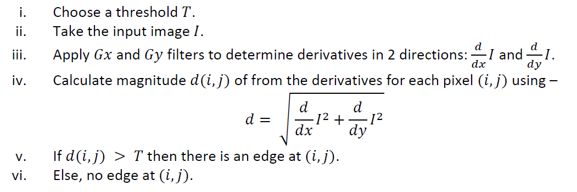

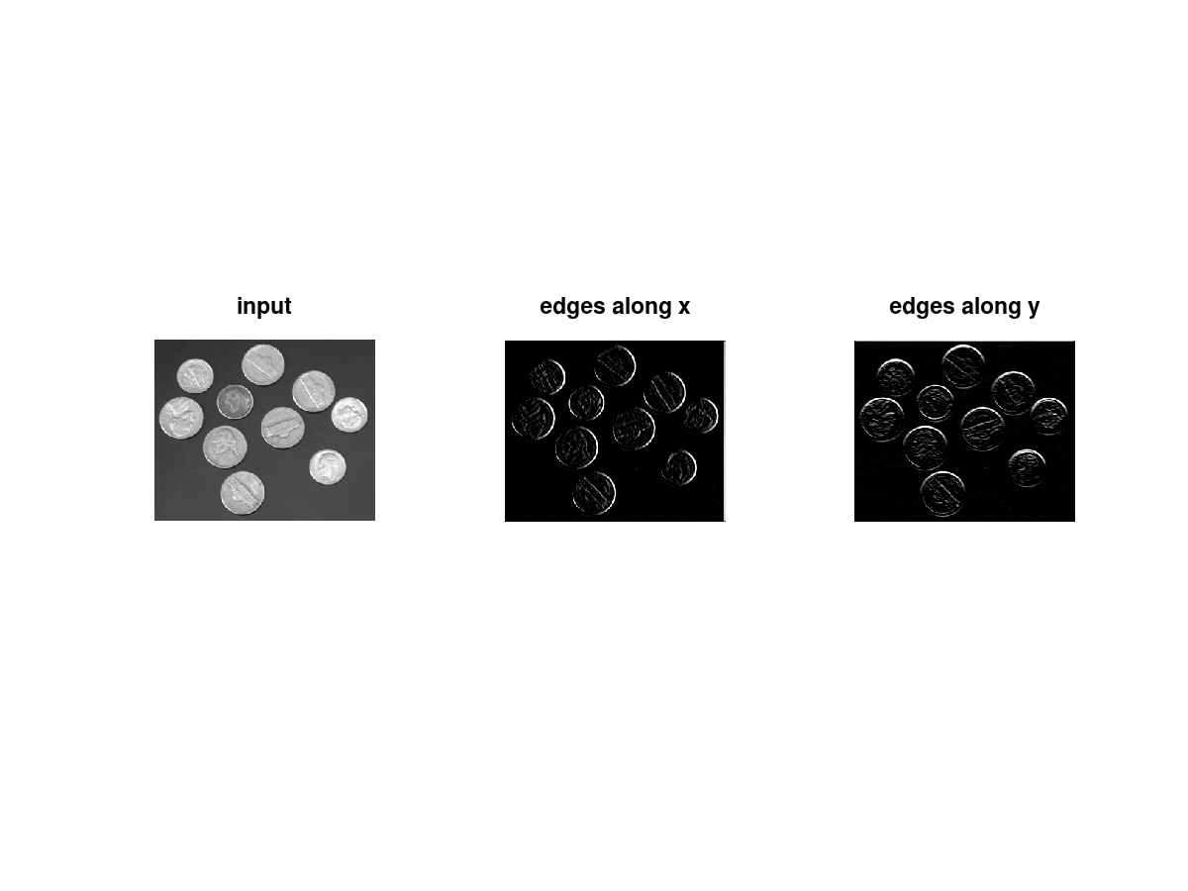

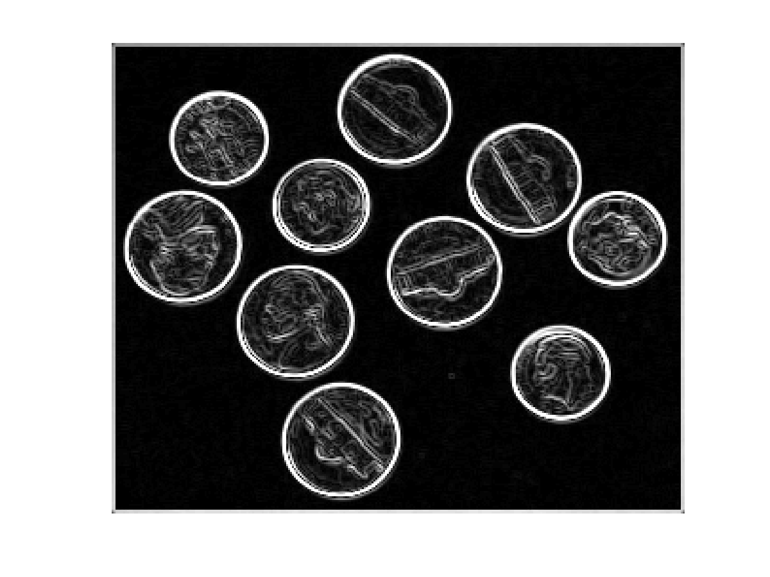

1. Sobel Edge Detection:

Gx = [-1 0 1;

-2 0 2;

-1 0 1];

Gy = [ 1 2 1;

0 0 0;

-1 -2 -1];

*This mask works exactly the same as the Prewitt operator mask. There is only one difference that is it has “2” and “-2” values in the center of the first and third rows and columns. When applied to an image this mask will highlight the edges.*

Steps:

